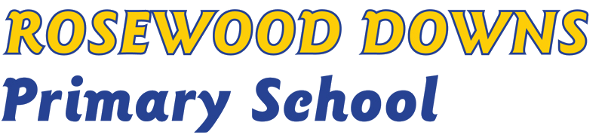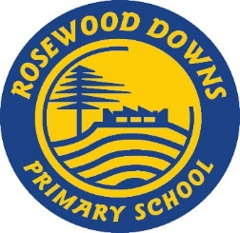

**RESPECT FOR SCHOOL STAFF POLICY**

**Help for non-English speakers**

If you need help to understand the information in this policy please contact the Assistant Principal.

## **Purpose**

To ensure that members of our community understand Rosewood Downs Primary School expectations for appropriate interactions with school staff.

## **Policy**

Staff at Rosewood Downs Primary School, including teachers, education support staff, office staff, the Assistant Principal/s and Principal are committed to providing a positive and supportive learning environment for all our students. Our staff take their work very seriously and feel privileged to be able to play an important role in each child’s education.

Parents/carers and visitors to our school also have an important role to play in fostering a safe and inclusive environment for the entire school community.

## Respectful behaviours within the school community

All staff at Rosewood Downs Primary School have a right to a safe and supportive work environment, and we expect that parents/carers and visitors behave in an appropriate and respectful manner at all times.

## The Department of Education and Training has outlined expectations on parent/carer behaviour within Victorian government school communities in the [Respectful Behaviours within the School Community Policy.](https://www.education.vic.gov.au/Pages/Respectful-Behaviours-within-the-School-Community-Policy.aspx)

## Unacceptable behaviours

When parents and carers engage in unacceptable behaviours against a staff member of another member of the school community, this can affect their health, safety and wellbeing.

Unacceptable behaviours include, but are not limited to:

* being violent or threatening violence of any kind, including physically intimidating behaviour such as aggressive hand gestures or invading another person’s personal space
* speaking or behaving in a rude, aggressive or threatening way, either in person, via email, social media, or over the telephone
* sending demanding, rude, confronting or threatening letters, emails or text messages
* discriminatory or derogatory comments
* the use of social media or public forums to make inappropriate or threatening remarks about the school, staff or students.

At the Principal’s discretion, unacceptable behaviour may be managed by:

* requesting that the parties attend a mediation or counselling sessions
* implementing specific communication protocols
* written warnings
* conditions of entry to school grounds or school activities
* exclusion from school grounds or attendance at school activities
* reports to Victoria Police
* legal action

The Principal may also seek support from Department of Education and Training staff when managing unacceptable parent or carer behaviour.

Respectfully raising complaints

We welcome complaints from parents and carers if they are communicated in a respectful and constructive way. Complaints and concerns raised with us can help our school community by providing feedback to improve how our school operates.

When raising a complaint or concern with us, Rosewood Downs Primary School expects all members of our community to act consistently with this policy, our *Statement of Values and School Philosophy* and the Department’s[Respectful Behaviours within the School Community Policy](https://www.education.vic.gov.au/Pages/Respectful-Behaviours-within-the-School-Community-Policy.aspx).

For information on how to raise a complaint or concern with our school, refer to our Rosewood Downs Primary School Parent Complaints and Concerns Policy.

The [Family Engagement in Learning](https://www.education.vic.gov.au/PAL/family-engagement-in-learning.docx) is also a useful Department resource outlining how parents and carers can best engage with schools to provide feedback, suggestions and complaints.

**COMMUNICATION**

This policy will be communicated to our school community in the following ways:

* Available publicly on our school’s website
* Hard copy available from school administration upon request

## **RELATED POLICIES and resources**

Department of Education and Training policies and resources:

* [Work-Related Violence in Schools Policy](https://www2.education.vic.gov.au/pal/occupational-violence-and-aggression-schools/policy)
* [Respectful Behaviours within the School Community Policy](https://www.education.vic.gov.au/Pages/Respectful-Behaviours-within-the-School-Community-Policy.aspx)
* [Family engagement in learning](https://www.education.vic.gov.au/PAL/family-engagement-in-learning.docx)

Rosewood Downs Primary School polices:

* Parent Complaints and Concerns Policy
* Statement of Values and School Philosophy

**POLICY REVIEW AND APPROVAL**

|  |  |
| --- | --- |
| Policy last reviewed | August 2022 |
| Approved by | Principal |
| Next scheduled review date | By August 2024 |