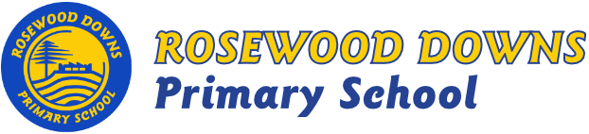

Term 3, 2019
Unit C – Grades 3and 4

Topic: “Whatever Floats Your Boat”
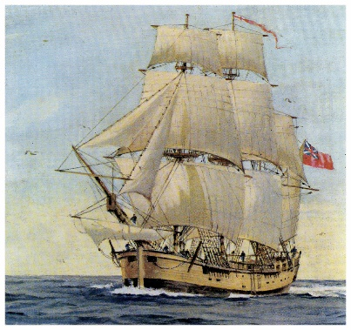
Curriculum Areas:
History & Geography- “The First Fleet”
Science- Physical Science – “Energy and Change”

English Focus:

Guided Reading
Teaching Comprehension Strategies
CAFÉ Literacy
Comprehension, Accuracy, Fluency and Expand Vocabulary

Seven Steps Writing Program
Planning for Success, Ban the Boring Bits
VCOP writing program
Vocabulary, Connectives, Openers and Punctuation.
(Weekly ‘Big Write’ sessions)
Maths Focus:
- Number & Algebra: Addition, subtraction, multiplication, division, decimals fractions, money and place value
- Measurement & Geometry: Mapping, time, angles, units of measurement and 2D and 3D shapes
- Statistics & Probability: Data collection & investigations, picture graphs and column graphs.

Minor Curriculum Areas:
Social and Emotional Learning
- Bounce Back – Relationships, Bullying
- Think Plus – Growth Mindsets

