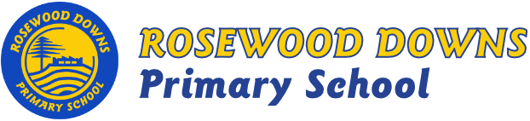
Unit B – Grade 5 & 6
Term 3, 2019

Topic: Out of This World
A bit about what is happening this term …

- Grade 6 Musical
- Poetry.

Major Curriculum Areas:

Literacy Focus:

- Guided Reading Groups
- Independent Reading
- Reader’s Theatre
- Reading by Genre
- Writing songs and poetry
- Literature Program
Mathematics Focus:

- Number & Algebra: Place value, multiplication, division, factors, multiples, decimals, fractions, order of operations, patterns, financial mathematics and economics
- Measurement & Geometry: Understanding and constructing shapes, planning and mapping.
- Statistics & Probability: Graphing and data displays.

Minor Curriculum Areas:

- Social and Emotional Learning
- Resilience Project – Gratitude, empathy, mindfulness, emotional literacy.
- Drug Education
- Science
- Design, Creativity and Technology
Highlights:

- Grade Six Musical
- STOMP!

