Term 3, 2019
Unit A – Prep

Topics: Staying Alive (Science)
My World (History)
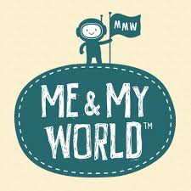
In Term 3 the Prep students learn in science that we need food, water and shelter to stay alive.
Students will also learn that all families are special and unique. They will have the opportunity to share information about their family members with the rest of their class.

Major Curriculum Areas:
Science – Biological Science – Know and understand the basic needs of living things.
History – My World – Understand that all families are different.

English focus:
- Reading
  - CAFÉ Literacy: Comprehension, Accuracy, Fluency, Expand Vocabulary.
  - Daily 5: Read to self, Read to Someone, Listen to Reading.
- Writing
    - Journal writing
    - Retell
- Handwriting: Correct formation, direction, placement and size.
- Listening: Listen with attention during class activities and respond with statements and questions.
- Speaking: Show confidence when presenting to a group.

Maths Focus:
- Number & Algebra: Numbers, addition, subtraction and patterns.
- Measurement & Geometry: 2D and 3D shapes, time, length and mass.
- Statistics & Probability: Collection and analysis of data.
Minor Curriculum Areas:
Social and Emotional Learning
- Bounce Back – Relationships, No Bullying
- Resilience Project – Mindfulness
- Think Plus – Neuroplasticity & Mindsets

