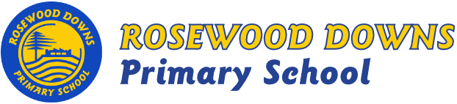

Term 3, 2019
Unit D – Grade 2

TOPIC: ALL CREATURES GREAT AND SMALL
A bit about what is happening this term …
This term the children will learn about how living things grow, change and have offspring similar to themselves.
They will be visiting Werribee Open-range Zoo and children will use ‘Student Voice’ to contribute to the planning of this excursion.
In History, children will learn how daily life may have changed over time.
In Geography, children will learn that places can be represented on maps and models

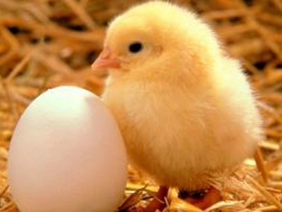

Major Curriculum Areas:
Biological Science
History
Geography

English focus:
- Reading
  - CAFÉ Literacy: Comprehension, Accuracy, Fluency, Expand Vocabulary.
  - Daily 5: Read to self, Read to Someone, Listen to Reading, Work with Words, Work on Writing.
- Writing
    - Procedural
    - Information Reports
    - Imaginative
    - Persuasive
    - Poetry
- Handwriting: correct formation, direction, placement and size.
- Listening: Develop appropriate listening skills, listening with intent.
- Speaking: Conventions of respectful speaking.

Maths Focus:
- Number & Algebra: Numbers, addition, subtraction, multiplication, division, patterns, fractions, decimals, equations.
- Measurement & Geometry: Time, 2D shapes, 3D objects, length, capacity and location.
- Statistics & Probability: Probability and data representation.

Minor Curriculum Areas:
Australian School Values.
Think Plus – Mindsets.
Social and Emotional Learning - Bounce Back: Strategies for Friendship, Loyalty and No Bullying!

