STUDENT ENGAGEMENT & WELLBEING POLICY
2018

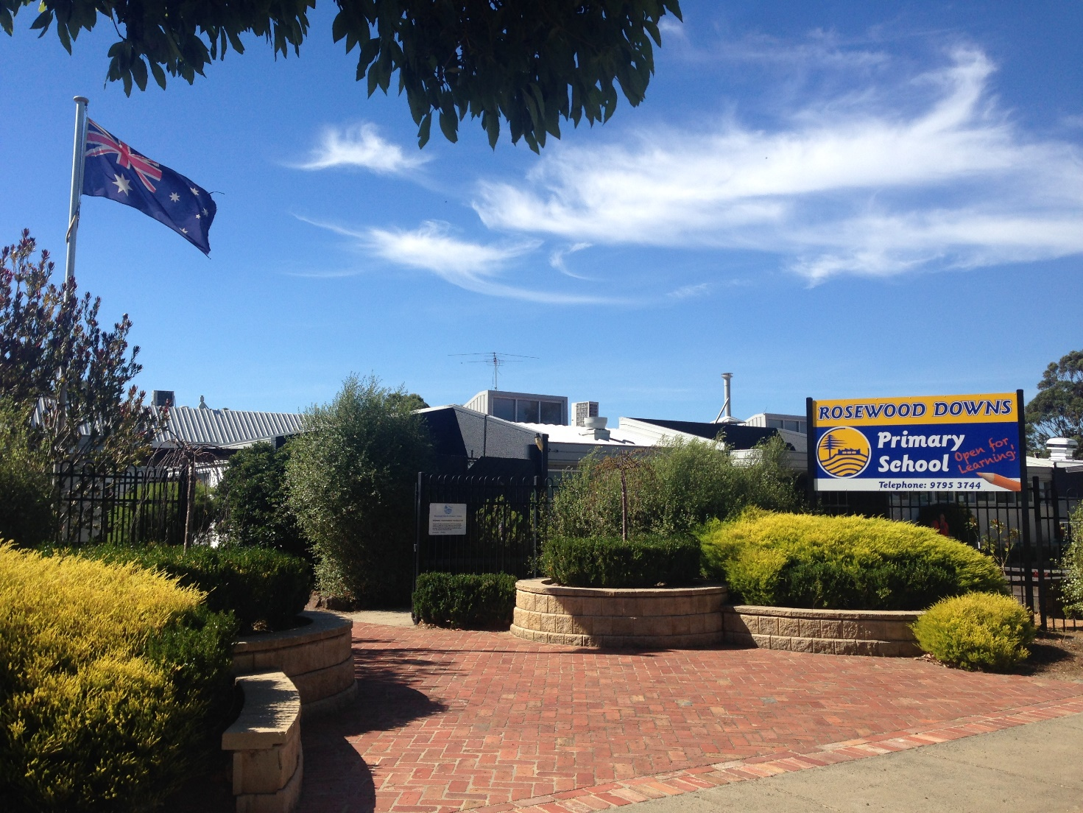

Purpose
The purpose of this policy is to ensure that all students and members of our school community understand:
- our commitment to providing a safe and supportive learning environment for students
- expectations for positive student behaviour
- support is available to students and families
- our school’s policies and procedures for responding to inappropriate student behaviour.
Rosewood Downs Primary School is committed to providing a safe, secure and stimulating learning environment for all students. We understand that students reach their full potential only when they are happy, healthy and safe, and that a positive school culture helps to engage students and support them in their learning. Our school acknowledges that student wellbeing and student learning outcomes are closely linked.
The objective of this policy is to support our school to create and maintain a safe, supportive and inclusive school environment consistent with our school’s values.
Scope
This policy applies to all school activities, including camps and excursions.
Contents
School profile
School values, philosophy and vision
Engagement strategies
Identifying students in need of support
Student rights and responsibilities
Student behavioural expectations
Discipline
Equity
Engaging with families
Child safe Standards
Statement of Commitment
Child Safe Policy (child friendly language)
Evaluation
Appendices 1. Restorative Practice
2. Consequences of Discipline Code Breaches
3. General school Rules
Policy
School Profile
Rosewood Downs Primary school is located in an established residential area in the South Eastern Outer Metropolitan area and draws children from diverse cultural backgrounds. The school has a current enrolment of 304 students with a high percentage of these students from ethnic backgrounds. Over 50% of students have a language background other than English. The great majority of these students are Australian born and reflect the strong multi-cultural influence on the past development of the area. The school's SFO has remained relatively stable and sits at 0.53 in 2018. 30% of our students receive CSEF Funding and we currently have six students who receive funding under the Program for Students with Disabilities. As predicted by DET, the school has experienced a gradual decline since 2014 of 367 students, to our current enrolment of 304. The school has a very cohesive staff with a blend of beginning through to experienced teachers. There is a low staff turnover creating a stable and consistent teaching environment.
The school is comprised of four open-plan units, each housing four teaching areas, a library, an art/craft room, an ICT Lab, a general purpose room and a multi-purpose gymnasium with a music room. The architectural design, complemented by extensively landscaped grounds, fosters whole school programs, team teaching, co-operative learning and integrated curriculum. Student responsibility and co-operation is supported by a positive welfare and discipline policy. We have a Junior School Council made up of representatives from Years 3-6 and a comprehensive Year Six Leadership Program. The school offers the Victorian Curriculum, implemented through a school based instructional model. The school is strongly committed to developing the individual potential of every child through a focus on personalised learning. Students are given the opportunity to monitor and manage their learning through structured support. Every student has a Personalised Learning Journal and sets weekly goals. Students participate in student led conferences that enable them to reflect on their learning and with support, set future goals.
Additional activities and initiatives include an annual School Musical Production, performance groups and bands, sporting activities, Perceptual Motor Program, Gardening, ThinkPlus, Community Garden, Camping Program and swimming. The school has developed programs in Literacy Intervention, Social and Emotional Wellbeing through KidsMatter, Mandarin, and Year to Year transition called the UP-Program and pre-school to prep transition. We have developed close ties with Lyndale Secondary College where our students attend a range of activities including a comprehensive Science Program for Year 5 and Year 6. In addition, Lyndale Secondary College provides teachers fortnightly, in both Numeracy and Literacy to run extension programs for our senior students.
We strive to provide a nurturing and challenging environment that empowers students to reach their personal best, both academically and socially.

School values, philosophy and vision
Vision

Rosewood Downs Primary School is committed to providing a learning environment and educational programs that will motivate, challenge and support students to become life-long learners. The school aims to maximise student potential in a safe and caring community in which academic achievement, positive self-esteem, cultural diversity and the rights of all are highly valued and respected. Rosewood Downs Primary School has a strong commitment to child safety and to protecting children from abuse.

Philosophy
The Rosewood Downs Primary School community believes that education is a framework for life. Students are supported and encouraged to become independent learners, able to exercise every opportunity to extend their knowledge and understanding of their academic, emotional and social environments.
Rosewood Downs Primary School is to provide for the academic and personal development of all students by:
- Creating a positive learning environment which will instil an eagerness for learning
- Prioritising the fundamental skills of Literacy and Numeracy
- Fostering the development of personal and social values
- Accepting and welcoming diversity

Rosewood Downs Primary School believes in the importance of providing a holistic approach to educating students. There is a whole school approach to children’s mental health and wellbeing under the umbrella of KidsMatter. We believe that being mentally healthy is vital for leading a rewarding life. KidsMatter addresses mental health promotion, prevention and early intervention. We are also a founding member of ThinkPlus. ThinkPlus fosters the development of growth mindsets and gives students positive, practical brain knowledge to learn more effectively. The key to ThinkPlus is the concept that intelligence can be developed. KidsMatter and ThinkPlus are infused through all key learning areas enabling our young learners to become resilient, persistent, creative and mindful.
Values

Rosewood Downs Primary School embraces and actively supports the Values for Australian Schooling:
- Care and Compassion
- Doing Your Best
- Fair Go
- Freedom
- Honesty and trustworthiness
- Integrity
- Respect
- Responsibility
- Understanding, Tolerance and Inclusion
- Generosity (school community value)

Engagement Strategies
Rosewood Downs Primary School takes a whole school approach to student wellbeing. We focus strongly on developing positive and respectful relationships, considering a positive approach to behaviour essential. We promote a school climate within which personal responsibility, positive self-esteem and self-discipline will be developed. These behaviours will be reinforced through the implementation of KidsMatter using programs including: Restorative Justice, Australian Values, BounceBack!, The Resilience Project and Kids Hope. We acknowledge that some students may need extra social, emotional or educational support at school, and that the needs of students will change over time as they grow and learn.
A summary of the whole of school, targeted (year group specific) and individual engagement strategies used by our school is included below:

Whole School
- High and consistent expectations of all staff, students and parents and carers
- Prioritise positive relationships between staff and students, recognising the fundamental role this plays in building and sustaining student wellbeing
- Creating a culture that is inclusive, engaging and supportive
- Welcoming all parents/carers and being responsive to them as partners in learning
- Analysing and being responsive to a range of school data such as attendance, attitudes to school survey, parent survey data, student management data and school level assessment data
- Deliver the Victorian Curriculum in a differentiated manner to ensure that all students learning needs are met
- Teachers at Rosewood Downs Primary School use an instructional framework to ensure an explicit, common and shared model of instruction that is evidenced-based using high impact teaching strategies
- Teachers at Rosewood Downs Primary School adopt a broad range of teaching and assessment approaches to effectively respond to the diverse learning styles, strengths and needs of our students and follow the standards set by the Victorian Institute of Teaching
- Our school’s statement of values are incorporated into our curriculum and promoted to students, staff and parents so that they are shared and celebrated as the foundation of our school community
- Carefully planned transition programs to support students moving into different stages of their schooling
- Positive behaviour and student achievement is acknowledged in the classroom, and formally in school assemblies and communication to parents
- Monitor student attendance and implement attendance improvement strategies at a whole-school, cohort and individual level
- Students have the opportunity to contribute to and provide feedback on decisions about school operations through the junior school council and other forums including classroom meetings. Students are also encouraged to speak with their teachers, year level coordinator, assistant principal and principal whenever they have any questions or concerns.
- Create opportunities for cross-age connections amongst students through play, sporting activities, music programs and peer support programs
- All students are welcome to self-refer to any staff member or member of the leadership team if they would like to discuss a particular issue or feel as though they may need support of any kind. We are proud to have an ‘open door’ policy where students and staff are partners in learning
- We engage in school wide positive behaviour support with our staff and students, which includes programs such as: Kidsmatter
ThinkPlus
Resilience Project
BounceBack!
- programs sourced to address issue specific behaviour (i.e. social skilling programs)
- opportunities for student inclusion (i.e. sports teams and lunchtime activities)
- buddy programs
Targeted
- classroom teachers monitor the health and wellbeing of students in their class and together with wellbeing staff act as a point of contact for students who may need additional support
- students in Prep and Grade 5 participate in a buddy program using resources from the Alannah and Madeline Foundation
- kinder children attend a transition program over terms two, three and four
- grade 6 children attend transition programs run by their chosen secondary school
- grade 6 student leadership
- all students participate in a transition program – the Up Program – in the final weeks of the school year to familiarise them with their new class and teacher for the following year
- connect all Koorie students with a Koorie Engagement Support Officer
- all students in Out of Home Care will be appointed a Learning Mentor, have an Individual Learning Plan and will be referred to Student Support Services for an Educational Needs Assessment
- classroom teachers will undertake health promotion and social skills development in response to needs identified by student wellbeing data or other school staff each year
- staff will apply a trauma-informed approach to working with students who have experienced trauma
Individual
- Student Support Groups, see: http://www.education.vic.gov.au/school/principals/spag/participation/pages/supportgroups.aspx
- Individual Learning Plan and Behaviour Support Plan
- Program for Students with Disabilities
- referral to Student Welfare Coordinator and Student Support Services
- referral to Child First, Headspace, ELMHS, Monash Health, Beyond Blue
- Lookout
Rosewood Downs Primary school implements a range of strategies that support and promote individual engagement. These include:
- building constructive relationships with students at risk or students who are vulnerable due to complex individual circumstances
- meeting with students and their parent/carer to talk about how best to help the student engage with school
- developing an Individual Learning Plan and/or a Behaviour Support Plan
- considering if any environmental changes need to be made, for example changing the classroom set up
- referring the student to:
  - school-based wellbeing supports
  - Student Support Services
  - Appropriate external supports such as council based youth and family services, other allied health professionals, headspace, child and adolescent mental health services or Child First
Where necessary the school will support the student’s family to engage by:
- being responsive and sensitive to changes in the student’s circumstances and health and wellbeing
- collaborating, where appropriate and with the support of the student and their family, with any external allied health professionals, services or agencies that are supporting the student
- monitoring individual student attendance and developing an Attendance Improvement Plan in collaboration with the student and their family
- running regular Student Support Group meetings for all students:
  - with a disability
  - in Out of Home Care
  - with other complex needs that require ongoing support and monitoring.
Rosewood Downs has created a friendly, caring and purposeful, responsible and cooperative school climate where children, teachers and parents work together towards the realisation of common goals.
Identifying students in need of support
Rosewood Downs Primary School is committed to providing the necessary support to ensure our students are supported intellectually, emotionally and socially. The Student Wellbeing team plays a significant role in developing and implementing strategies to help identify students in need of support and enhance student wellbeing. Rosewood Downs Primary School will utilise the following information and tools to identify students in need of extra emotional, social or educational support:
- personal, health and learning information gathered upon enrolment and while the student is enrolled
- attendance records
- academic performance
- observations by school staff such as changes in engagement, behaviour, self-care, social connectedness and motivation
- attendance, detention and suspension data
- engagement with families
- self-referrals or referrals from peers

Student rights and responsibilities
All members of our school community have a right to experience a safe and supportive school environment. We expect that all students, staff, parents and carers treat each other with respect and dignity. Our school’s Statement of Values highlights the rights and responsibilities of members of our community.
Students have the right to:
- participate fully in their education
- feel safe, secure and happy at school
- learn in an environment free from bullying, harassment, violence, discrimination or intimidation
- express their ideas, feelings and concerns.
Students have the responsibility to:
- participate fully in their educational program
- display positive behaviours that demonstrate respect for themselves, their peers, their teachers and members of the school community
- respect the right of others to learn.
Behavioural expectations of students, staff and families are grounded in our school’s Statement of Values. Student bullying behaviour will be responded to consistently with Rosewood Downs Primary School’s Bullying Prevention Policy.
In encouraging a safe, orderly and harmonious learning environment, Rosewood Downs Primary School will use a combination of restorative practice/mediation and discipline.

When a student acts in breach of the behaviour standards of our school community, Rosewood Downs Primary School will institute a staged response, consistent with the Department’s Student Engagement and Inclusion Guidelines. Where appropriate, parents will be informed about the inappropriate behaviour and the disciplinary action taken by teachers and other school staff.

Student Behavioural Expectations
Rosewood Downs Primary School aims to achieve a cooperative working atmosphere where all members of the school community show respect and fairness for themselves, towards others and for school property and the property of others. The school emphasises a positive code of behaviour by establishing the rules for the orderly functioning of the school.

We aim to develop in children a sense of responsibility for their own behaviour, and an awareness of the consequences of undisciplined behaviour. To implement this effectively, both school and parents need to recognize their common interest, and the importance of a cooperative approach. The same standards of behaviour are expected of all students. The process of learning responsibility and self-discipline is a gradual one, and the school takes into account the age and educational level of the child when deciding the best way to handle a problem situation.

Rosewood Downs Primary School has a strong commitment to the development of relationships with all members of the school community. The building of these relationships is a cornerstone of the school ethos. In support of this, consequences for actions are dealt with using Restorative Justice Practices.
We consider a positive approach to behaviour essential. We promote a school climate within which personal responsibility, self-esteem and self-discipline will be developed.
At Rosewood Downs Primary School we:
- establish predictable, fair and democratic classroom environments
- ensure student participation in the development of classroom and whole school expectations
- provide personalised learning programs
- consistently acknowledge all students
- empower students by creating multiple opportunities for them to take responsibility and to be involved in decision making
- provide physical environments conducive to positive behaviours and effective engagement in learning
- implement school wide positive and educative behaviour support strategies
Units
Each Unit has developed a behaviour management plan that complements the Student Engagement Policy. This plan is discussed with the students and a copy of this is distributed to all parents. Teachers may contact parents at any time. Parents are also encouraged to contact the school if they have any concerns regarding their child.
Playground behaviour
Teachers on duty are to deal with any issues in the yard. All issues are to be followed up by the teacher who receives the report or sees the incident. Teachers may choose to ‘walk and talk’ with children who have been involved in a misdemeanour which provides the opportunity for students to understand and resolve issues.
Discipline
Children who display dangerous or anti-social behaviour will be removed from the playground and taken to the Assistant Principals or Principal. Dangerous behaviour may result in automatic detention, to be supervised by the Assistant Principals or Principal or an immediate suspension.
Disciplinary measures may be used as part of a staged response to inappropriate behaviour in combination with other engagement and support strategies to ensure that factors that may have contributed to the student’s behaviour are identified and addressed. Disciplinary measures at our school will be applied fairly and consistently. Students will always be provided with an opportunity to be heard.
A Staged Response

- To establish an understanding of the individual student and their life circumstances, the school will engage the family during the first interview, to begin to establish a positive rapport.
- The restorative practice approach is used when talking to students and will be embedded in classroom teaching and learning.
- Serious incidents will require a formal approach with the classroom teacher applying classroom management strategies and/or the teacher on yard duty reminding students of conduct that is most appropriate. If appropriate the teacher will refer the incident to the relevant unit manager/Assistant Principal and submit an incident form outlining inappropriate behaviour and how the behaviour has been managed.
- Discussion will take place about the best course of action for the individual or groups of students. This could be a punitive consequence and/or restorative.
- Where appropriate the Assistant Principal will liaise with agencies such as: psychologists, DHHS, CAMHS, Child First. There will be situations where a formal conference involving key stakeholders and a convenor will be required.
- Any imposed consequence will be imbedded in the restorative process that requires a response ‘that makes things right’ in relation to those who have been affected. Where a restorative approach has previously been conducted and subsequently the behaviour continues, the school will constitute a Student Support Group to devise strategies and approaches to address the behaviour; this may include intervention from specialist services and external agencies in the local community.
- An individualised timetable may also be considered for some students.

Disciplinary measures that may be applied include:
- warning a student that their behaviour is inappropriate
- teacher controlled consequences such as moving a student in a classroom or other reasonable and proportionate responses to misbehaviour
- withdrawal of privileges
- referral to the unit Manager
- referral to a member of the Leadership Team
- restorative practices
- detentions
- behaviour reviews
- suspension
- expulsion
Suspension and expulsion are measures of last resort and may only be used in particular situations consistent with Department policy, available at: http://www.education.vic.gov.au/school/principals/spag/participation/pages/engagement.aspx

Corporal punishment is prohibited in our school and will not be used in any circumstance.

Engaging with families
Rosewood Downs Primary School values the input of parents and carers, and we will strive to support families to engage in their child’s learning and build their capacity as active learners. We aim to be partners in learning with parents and carers in our school community.
We work hard to create successful partnerships with parents and carers by:
- ensuring that all parents have access to our school policies and procedures, available on our school website
- maintaining an open, respectful line of communication between parents and staff, supported by our Communicating with School Staff policy.
- providing parent volunteer opportunities so that families can contribute to school activities
- involving families with homework and other curriculum-related activities
- involving families in school decision making
- coordinating resources and services from the community for families
- including families in Student Support Groups, and developing individual plans for students.
Parents/carers will be expected to promote positive educational outcomes for their children by taking an active interest in their child’s educational progress. Parental cooperation with school, including regular and constructive communication with school staff regarding their child’s learning and wellbeing, will actively support their child’s engagement in the school environment.
Parents/carers will be expected to support the school in maintaining a safe and respectful learning environment for all students.
Expectations of Parents/Carers
- provide support for their children while attending the school
- cooperate with requests from the school
- promote positive educational outcomes for their children
- ensure their children are attending school regularly
- communicate clearly with the school about the needs of their children
Equity
Members of the Rosewood Downs school community can expect to be treated fairly with equal opportunity for all. In order to be treated fairly, people may not all be treated in the same way. Consideration will be made for individual differences and circumstances.

Child Safe Standards
Registered schools have an important responsibility for keeping children safe. All registered schools are required to develop strategies to embed a culture of child safety. Creating safe places for children to fully and actively participate in the life of the community benefits everyone. Schools and other organisations have an obligation to comply with the new Victorian child safe standards. All children have the right to feel safe and to be safe all of the time, but safety does not just happen. The work that is involved in building a child safe organisation is ongoing. It is a dynamic, multifaceted developmental process of learning, monitoring and reviewing. We have all been entrusted with an obligation to do the best we possibly can to keep our children safe from harm.
Statement of Commitment to Child Safety at Rosewood Downs Primary School
Rosewood Downs Primary School is committed to the safety and wellbeing of all children and young people. This is the primary focus of our care and decision-making, with particular attention paid to the cultural safety of Aboriginal children and children from culturally and/or linguistically diverse backgrounds, as well as the safety of children with a disability. Rosewood Downs Primary School has zero tolerance for child abuse. Rosewood Downs Primary School is committed to providing a child safe environment where children and young people are safe and feel safe and their voices are heard about decisions that affect their lives.

Every person involved in Rosewood Downs Primary School has a responsibility to understand the important and specific role he/she plays individually and collectively to ensure that the wellbeing and safety of all children and young people is at the forefront of all they do and every decision they make.

In its planning, decision-making and operations, Rosewood Downs Primary School will:
- Take a preventative, proactive and participatory approach to child safety
- Value and empower children to participate in decisions which affect their lives
- Foster a culture of openness that supports all persons to safely disclose risks of harm to children
- Respect diversity in cultures and child rearing practices while keeping child safety paramount
- Provide written guidance on appropriate conduct and behaviour towards children
- Engage only the most suitable people to work with children and have high quality staff and volunteer supervision and professional development
- Ensure children know who to talk with if they are worried or are feeling unsafe and that they are comfortable and encouraged to raise such issues
- Report suspected abuse, neglect or mistreatment promptly to the appropriate authorities
- Share information appropriately and lawfully with other organisations where the safety and wellbeing of children is at risk
- Value the input of and communicate regularly with families and carers

Child Safe Policy
For Children

Rosewood Downs Primary School is committed to providing a child safe environment where children and young people are safe

Rosewood Downs Primary School has a zero tolerance for child abuse

It is everyone’s responsibility to ensure the wellbeing and safety of all children

Children are encouraged to speak up if they are worried and we make sure that they know who to talk to if they are feeling unsafe

We make sure that children are involved in making decisions which affect their lives

We respect all members of the Rosewood Downs Primary School community

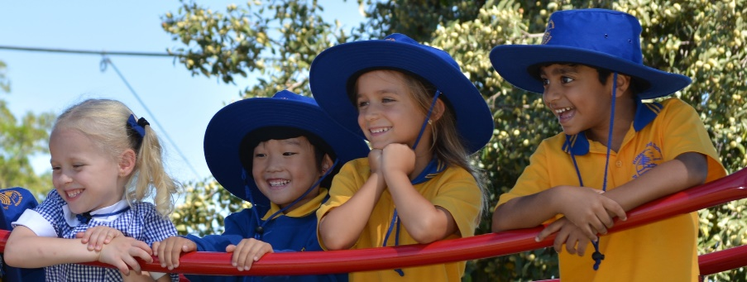

Evaluation
Rosewood Downs Primary School will collect data each year to understand the frequency and types of wellbeing issues that are experienced by our students so that we can measure the success or otherwise of our school based strategies and identify emerging trends or needs.
Sources of data that will be assessed on an annual basis include:
- student survey data
- incidents data
- school reports
- parent survey
- case management
- CASES21
- SOCS

Further Information and Resources
Related Policies:
- Attendance Policy
- Bullying Prevention Policy
- Child Safe Policy
- Communication with School Staff Policy
- Inclusion and Diversity Policy
- First Aid Policy
- Duty of Care Policy
- Supervision and Yard Duty Policy

Review Period
This policy was last updated on 23/05/2018 and is scheduled for review in May 2019.

This policy was approved by School Council on 23/07/2018

Appendix 1
Restorative Practice
Dialogue to manage conflict:

To person who  had done harm:  Can you tell me  what happened?  What were you  thinking at the  time?  What have you  thought about  since then?  Who do you think  has been affected  by your  behaviour?  How do you think  they have been  affected? | To the person  who has been  affected:  What was your  reaction at the  time of the  incident?  How do you feel  about what  happened?  What did you  think at the time?  What have you  thought since  then?  How have you  been affected?  What has been the  hardest thing for  you? | To the person  who has done  harm:  Is there anything  else you want to  say? | To each person:  What would you  like to see happen  to repair the  harm?  Is this fair?  Is this realistic  and achievable?  (Could formally  record agreement  at this stage.) | To both people:  Is there anything  else you would  like to say?  I would like to  thank you for the  way we worked  through the  issues. (Maybe we  could meet again  soon to see how  things are going?)

Appendix 2
Consequences of Discipline Code Breaches
Each breach of the conduct code will be dealt with according to the severity of the offence. Restorative Justice Practices will be used and consequences put in place. Serious breaches will be dealt with by the Assistant Principals or Principal. Parents will be contacted
Breaches of Conduct will generally be at one of the following four levels.
Level One (Classroom based)
Every effort will be made to resolve the problem immediately by the teacher. Parents may be informed, an in-house detention during school hours may be given or the removal of privileges may occur. Classroom teachers will place an emphasis on positive behaviour in order to encourage this standard in the classroom and reward those who exhibit outstanding behaviour. Restorative Justice Circle time may be used to discuss behaviours or for problem solving. This ensures that the students understand the consequences and are part of the solution thus feeling empowered and positive.
Level Two (e.g. Dangerous or anti-social behaviour)
After consultation with the Assistant Principal and Unit Manager, a copy of the misconduct form will be completed, a detention given (during or after school) and a copy of the form sent to the parents. Teachers giving the detention are responsible for its implementation. Parents are contacted by phone to inform them of the incident and its consequences. A record of this will be kept by Unit Managers and on a school file. Restorative Justice Practices are implemented in order to mend broken relationships and determine consequences.
Level Three (e.g. Repeated misconduct)
Should repeated misconduct occur, a meeting will be organised between the parents, teacher and the Assistant Principals or the Principal, to decide further action. At this stage, we may offer support from the SSSO team or external agencies in order to support the student and their family. An ‘I have’ person is usually nominated by the student in order to provide him/her with extra support and pastoral care meetings are organised. This person is always available for the student at all times.
Level Four (e.g. Serious or repeated breaches of conduct code)
A misconduct form will be completed. This will be directly referred to the Principal who may exercise the options as outlined by the Department of Education and Training and ‘Student Engagement Guidelines’. These options include suspension, and in extreme cases, expulsion from school. Suspension and expulsion are not seen as a solution to the student’s or school’s problems. They are used sparingly and with parental support. Counselling is always provided for the student and the family.
At the beginning of each year, teachers and students will discuss and clarify the Code of Conduct. Families will be given a copy of the Student Code of Conduct and Unit Discipline Plan to review and discuss with their child. An agreement to support the Code of Conduct will be included. This agreement is to be signed by parents and children. Parents of younger children, after reading and discussing the Code of Conduct, may choose to sign on behalf of their child. Newly enrolled families will be given a copy at the time of enrolment to read and sign.

Rules for all Units and Specialist Teachers
- Everyone has the right to work, learn and play without being disturbed.
- Respect the rights and property of others.
Unit A (Prep) Consequences
- Warning.
- Child moved away from group but in class area.
- Child moved to another grade.
- Child removed to another unit if behaviour continues.
- If the disruption continues, or is extreme, discipline as outlined in the Student Code of Conduct will be followed.

Units B, C & D (Grades 1-6) Consequences

- A verbal warning will be given.
- Appropriate consequences - e.g. moved from seat if talking.
- Child moved away from group but in class area.
- Child moved to another grade. Work to be set as appropriate.
- Child removed to another unit if behaviour continues.
- Learning time lost through inappropriate behaviour may result in work being done at another time or at home.
- If the disruption continues or is extreme, discipline as outlined in the Code of Conduct will be followed.
- Phone call or note sent home to parent/guardian requesting an interview.

Specialist Teachers’ Consequences
- Verbal warning.
- Child removed from main group - 5 minutes ‘Time Out’. They will be allowed to re-join the activity if prepared to behave appropriately.
- If inappropriate behaviour continues, they will be isolated from the group and an alternative activity organised.
- If the disruption continues, or is extreme, discipline as outlined in the Student Code of Conduct will be followed.

Appendix 3

General School Rules

A focus on rewarding positive behaviour is more important than a focus on inappropriate actions. In a positive attempt to protect all school members, children are expected to adhere to the following rules:
School Uniform
    - Full school uniform to be worn at all times.
    - School hats to be worn in Terms 1 and 4. Those without hats must remain in the quiet area.

School Grounds
- Use playground equipment in a safe manner.
- The dangerous throwing of objects (including sticks and stones) is not acceptable.
- Objects must not be thrown over neighbour’s fences.
- The riding of wheeled vehicles is not permitted.
- Trees give us shade so we care for them by not climbing them.
- Garden beds are out of bounds.
- Children are not permitted to leave the school grounds without a teacher or parent.
- The fenced area on the mini oval and the area at the sides and behind the hall are out of bounds.

Play Areas
- Unit A play area is only for use by children in grade Prep. Older children must not run through this area.
- The area between Unit A and Unit B is only to be used for quiet activities. No ball games in this area.
- Only safe ball games on the asphalt. Ball games are not to be played on the basketball court under the sail after 8.30 each morning prior to assembly.

Buildings and Internal Walkways
- Always walk in and around school buildings.
- Children are not to be inside a building unless accompanied by a teacher.
- Internal walkways are only to be used when accompanied by a teacher.
- The white line near the library is the boundary for the quiet area. Children line up there when the library bell rings.

General
- Electronic devices, expensive items and other items of significant value are not to be brought to school.
- Data devices such as USBs, CDs and DVDs are not to be brought to school
- Mobile phones are to be handed into the office on arrival and collected after school.
- Interfering with another’s game, property or possessions is not allowed.
- Children are expected to display courtesy and respect at all times.

