Mental Health and Wellbeing Policy
Purpose
Leadership and staff acknowledge the importance of promoting positive mental health and wellbeing. This policy confirms our commitment to:
- providing a safe, welcoming and supportive environment
- promoting a culture of respect, fairness and equity
- embedding social and emotional learning into the curriculum
- ensuring families, students and staff are key partners in mental health and wellbeing initiatives
- engaging and working collaboratively with local health professionals.
As a health promoting school, Rosewood Downs will promote the mental health and wellbeing through learning, policies, creating a safe and healthy physical and social environment, and developing community links and partnerships.
Policy Statement
Background
Schools can play a key role in promoting mental health in all children, recognising that children’s learning and development is supported by environments that promote mental health. ¹
Mental health promotion in schools is about creating positive, safe and supportive environments, and providing opportunities to build and practise relationship skills, resilience and social and emotional competencies. All staff can be involved in mental health promotion as it relates to every area of the school – the culture, policies, curriculum and activities. ²
Whole school engagement
It is recognised that every member of Rosewood Downs Primary School has an impact on students’ health and can contribute to creating an environment that promotes positive mental health and wellbeing. All members of our school community including staff, families and volunteers will be supported to meet this policy.
Definitions
Mental health
Mental health is a state of social and emotional wellbeing in which a person can realise their abilities, engage in learning, cope with the normal stresses of life, and make a contribution to their community. ³
Resilience
The ability to bounce back from adversity in order to lead a healthy and fulfilling life. ⁴
Guidelines
Building capacity to promote mental health
School education staff must have the appropriate knowledge, skills and attitudes to promote mental health. These competencies need to be supported through professional practices that encourage staff to work together, and to build partnerships with other professionals. Competencies and practices include:

Professional competencies
- understanding children’s social and emotional development
- teaching and facilitating social and emotional learning and promotion of positive behaviour
- listening and facilitation skills
- understanding and promoting diversity
- development of personal social and emotional skills and awareness
Professional practices
- professional learning
- establishing communities of practice and networks
- connecting with mental health professionals
- building partnerships with community service organisations
- establishing and maintaining referral pathways
- connecting with relationships with other mental health initiatives
KidsMatter
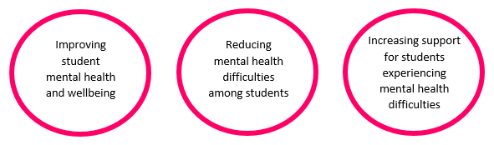
KidsMatter Primary aims to contribute to…

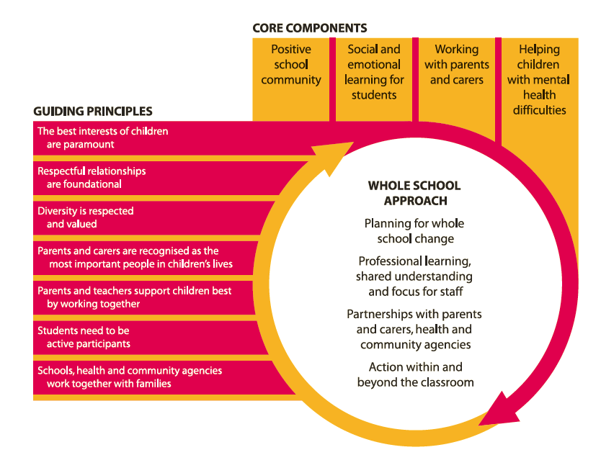
The KidsMatter framework supports planning and activity around the four components with seven Guiding Principles and a planned whole-school approach.

Social and emotional learning will be taught explicitly, regularly and in a coordinated way throughout the school.
Rosewood Downs has selected Bounce Back to effectively implement a social and emotional learning program that covers the five core competencies (self-awareness, self-management, social awareness, relationship skills and responsible decision-making).
Rosewood Downs has a Mental Health and Wellbeing Team with protocols and processes in place for recognising and responding to students with mental health difficulties.
Evaluation
Children who are mentally healthy:
- learn better and achieve more
- are motivated and committed
- have positive relationships
- are better able to meet life’s challenges
- can contribute to their families, friends and society in ways that are appropriate for their age
- manage transition to adolescence and adulthood more successfully ³
Monitoring and Review
The Mental Health and Wellbeing policy will be monitored and reviewed by the KidsMatter Action Team through the cyclical and ongoing KidsMatter Framework.

Ratified by Rosewood Downs School Council – October 2017

______________________________
- DEECD Promoting Health Minds for Living and Learning
http://www.education.vic.gov.au/Documents/school/teachers/healh/healthyminds.pdf
- DEECD ‘Building Mental Health Promotion Capacity
http://www.education.vic.gov.au/childhood/providers/health/Pages/building.aspx
- Raphael B. 2000, Promoting the mental health and wellbeing of children and young people. Discussion paper: key principles and directions. Canberra: Department of Health and Aged Care, National Mental Health Working Group retrieved from KidsMatter Early Childhood: A framework for improving children’s mental health and wellbeing 2012

- School Drug Education and Road Awareness. Challenges and Choices. Early Childhood Resources for resilience, drug and road safety education. Government of Western Australia, 2005

