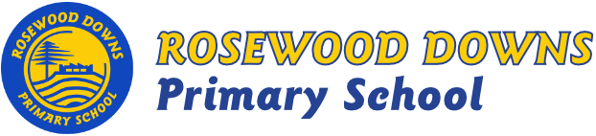

Term 3, 2018
Unit C – Grade 3

Topic: Night and day

Curriculum Areas:
Earth & Space Sciences -: Earth’s rotation on its axis causes regular
changes, including night and day.

Geography: Australia’s Places – Australia’s states and territories and major places.

Civics & Citizenship: Making decisions and making rules.

English Focus:
- Reading
  - CAFÉ Literacy: Comprehension, Accuracy, Fluency, Expand Vocabulary.
  - Daily 5: Read to Self, Read to Someone, Listen to Reading.
  - Guided Reading
- Writing
    - Report
    - Procedural Text
    - Poetry
- Handwriting: correct formation, direction, placement and size, joined cursive writing.
- Listening: Listening and understanding presentations and social interaction.
- Speaking: ‘My favourite book’ diorama presentations.

Maths Focus:
- Number & Algebra: Addition, subtraction, multiplication, division and fractions.
- Measurement & Geometry: Time, 2D shapes, 3D objects, length and area.
- Statistics & Probability: Probability and data representation.

Minor Curriculum Areas:
Think Plus – Growth Mindset
Social and Emotional Learning - Bounce Back

