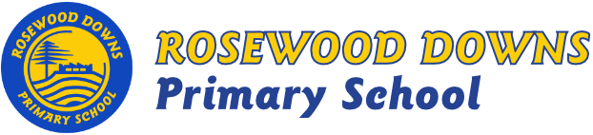

Term 3, 2018
Unit D – Grade 2

Topics: All Creatures Big & Small (Science)
Maps & Globes (Geography)
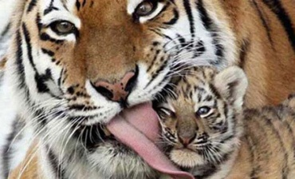
In Term 3 the Grade 2 students will be learning about how living things grow, change and have offspring similar to themselves.
Students will discover that places can be represented on maps and models.

Major Curriculum Areas:
- Science – Biological Science
- Geography – Geographical Knowledge
English focus:
- Reading
  - CAFÉ Literacy: Comprehension, Accuracy, Fluency, Expand Vocabulary.
  - Daily 5: Read to self, Read to Someone, Listen to Reading.
- Writing
  - Big Write: Narrative, Informational Report, Procedural Text, Poetry.
  - Little Write: Grammar and Punctuation.
  - VCOP: Vocabulary, Connectives, Openers, Punctuation.
- Handwriting: Correct formation, direction, placement and size.
- Listening: Listen with attention during class activities and take turns to make appropriate responses in conversation and to text.
- Speaking: Show confidence and use expression when presenting to a group, modify tone and pace of speech during discussions and presentations.
Maths Focus:
- Number & Algebra: Number sequences, addition, subtraction, number patterns, place value, money, multiplication, division, problem-solving.
- Measurement & Geometry: Time, 2D and 3D shapes, length, area, calendar, congruency, volume, transformation.
- Statistics & Probability: Probability and data representation.
Minor Curriculum Areas:
Social and Emotional Learning
- Bounce Back – Relationships, No Bullying
- Mindfulness
- Think Plus – Mindsets

