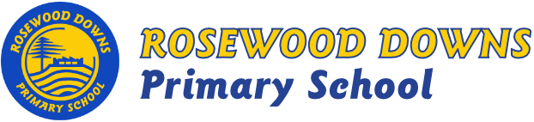

Term 3, 2018
Unit D – Grade 1

Topics: Wings and Things (Science)
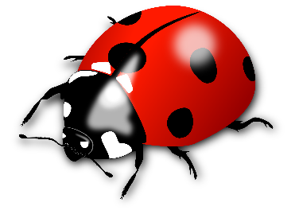
Significant Events in Our Lives (History)

In Term 3 the Grade 1 students will be inquiring about Minibeasts; Their life cycles and characteristics.
Students will celebrate milestones and significant events in their lives.

Major Curriculum Areas:
- Science – Biological Science
- History

English Focus:
- Reading
  - CAFÉ Literacy: Comprehension, Accuracy, Fluency, Expand Vocabulary.
  - Daily 5: Read to Self, Read to Someone, Listen to Reading.
- Writing
  - Recognise that text use different structures to suit their purpose with particular focus on: Letter Writing, Narrative & Persuasive Texts.
- Handwriting: Correct formation, direction, placement and size.
- Listening: Listen with attention during class activities and take turns to make appropriate responses in conversation and to text.
- Speaking: Show confidence and use expression when presenting to a group, modify tone and pace of speech during discussions and presentations.
Maths Focus:
- Number & Algebra: Subtraction, addition, introduction to multiplication, number patterns, and place value.
- Measurement & Geometry: Symmetry, capacity, shape, mass, time, length, location, and volume.
- Statistics & Probability: Data representation and interpretation.
Minor Curriculum Areas:
Social and Emotional Learning
- Values for Australian Schools
- Bounce Back – Relationships, No Bullying and Life Education
- Mindfulness
Think Plus – Growth Mindset, The Power of Yet, Peer Feedback
Weekly Individual Learning Journals – Goal setting and Reflections

