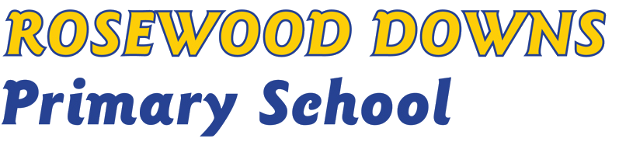
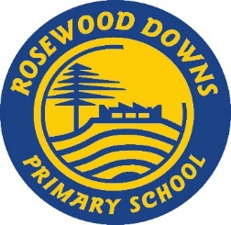

CURRICULUM FRAMEWORK POLICY

Purpose

Curriculum covers all the arrangements Rosewood Downs Primary School makes for students’ development and learning. The curriculum at Rosewood Downs Primary School encompasses the skills and knowledge that have been identified as essential learning and priorities for all students to understand and demonstrate. To achieve this, our Curriculum Framework Policy enables the development of a consistent, guaranteed and viable curriculum, taught and assessed across the School that is relevant, inclusive, collaborative, challenging and engaging to ensure that students are better equipped to deal with our changing world.

Policy:

Rosewood Downs Primary School’s curriculum is essential to give students skills in English, Science, Technologies, Arts, Mathematics, Health and Physical Education, Humanities, Language - Chinese, resilience, respectful relationships, the use of digital technologies and the capacity for critical and creative thinking and expression across all curriculum areas. These are skills students will need for work and life.

Definitions:
Professional Learning Community– an approach to school improvement and teacher professional learning where a group of teachers work collaboratively at the school level to improve student outcomes.
School Strategic Plan - Rosewood Downs Primary School's statement to its community about what it stands for and what it intends to do over the next four years to improve student outcomes. It outlines the school values, the school's direction, its goals, targets and key strategies for improvement.
Annual Implementation Plan - outlines how the School Strategic Plan will be implemented, monitored and evaluated. The plan contains the goals and targets from the School Strategic Plan, breaking these down into 12-month targets.
Action guidelines:
The Victorian Curriculum will be delivered from Prep to Year 6 at Rosewood Downs Primary School.
Rosewood Downs Primary School shall comply with all DET guidelines in regards to the length of student instruction time in Victorian schools and provides at least 25 hours of face-to-face student instruction per week.
The curriculum shall be collaboratively planned, assessed and reflected upon by all teachers, inclusive of specialist teachers.
Every child’s academic progress shall be closely monitored and teachers should implement best practices, using a variety of evidence based instructional and curriculum techniques to ensure that learning is targeted and that children are engaged with their learning.

Rosewood Downs Primary School shall provide a differentiated curriculum that recognises and responds to a diversity of learning capabilities, student needs, additional needs, and students from language backgrounds in addition to English. Educational Support staff complete our teaching team.
To guarantee curriculum consistency at Rosewood Downs Primary School, all teachers are required to follow the agreed directions of the Professional Learning Community
Rosewood Downs Primary School will document, through its School Strategic Plan and the Annual Implementation Plan, the key strategies for improvement in student learning outcomes as part of our curriculum plan.
Parents/carers will be provided with curriculum information via Newsletters, the Rosewood Downs Primary School website and in school notice boards. The school community is also kept fully informed of their child’s progress with face-to-face meetings, digital communication and twice yearly written reports.
Rosewood Downs Primary School will provide a Chinese language program for all students,

Monitoring, reporting and review:
Teachers will work and monitor implementation of the Rosewood Downs Primary School curriculum in collaborative learning teams, consistently referring to the School Strategic Plan and Annual Implementation Plan.
Professional Learning Community alignment will be monitored and supported through regular team meetings, consistently referring to the School Strategic Plan and Annual Implementation Plan.

Further Information & Resources
School Philosophy Statement
School Strategic Plan
Annual Implementation Plan

References:
Department of Education and Training (DET) http://www.education.vic.gov.au/Pages/sitemap.aspx
Victorian Curriculum and Assessment Authority (VCAA) http://www.vcaa.vic.edu.au/Pages/index.aspx
Australian Curriculum and Assessment and Reporting Authority (ACARA) https://www.acara.edu.au .

Review Period:
This policy was last updated on 25/05/2018 and is scheduled for review in May 2020.

